Hiyab Mengisteab
Task 1: Cloud Data Solution Planning

A. Requirements of a Cloud Data Solution
1. Discuss the functional requirements that must be considered when deciding on a cloud data storage solution for the provided scenario and why these requirements are important.
- Real-Time Data Ingestion and Processing: The system must support continuous, low-latency data ingestion and processing to enable immediate insights and timely decision-making in a fast-paced e-commerce environment.
- Seamless Integration: Compatibility with existing systems such as the e-commerce platform, customer relationship management (CRM) tools, and business intelligence (BI) solutions is essential to ensure smooth data flow across the organization.
- Support for Diverse Data Types: The solution should be capable of handling both structured and unstructured data to accommodate a wide range of data sources, including transactional records, user behavior logs, and vendor data.
- Scheduled ETL/ELT Pipelines: The ability to define and automate Extract, Transform, Load (ETL) or Extract, Load, Transform (ELT) processes on a scheduled basis is necessary for maintaining data consistency and preparing datasets for analysis and reporting.

2. Discuss the non-functional requirements that must be considered when deciding on a cloud data storage solution for the provided scenario and why these requirements are important.
- High Availability: The system must ensure uptime greater than 99.99% to support continuous, around-the-clock e-commerce operations without interruption.
- Scalability: The solution should automatically scale compute and storage resources to accommodate fluctuations in data volume and user activity.
- Security: Strong security measures such as data encryption (both in transit and at rest), identity and access management (IAM), and network isolation are critical to protect sensitive customer and transactional data.
- Regulatory Compliance: The solution must comply with regulations to meet legal and industry standards for data protection.
- Cost Efficiency: A pay-as-you-go pricing model with built-in cost tracking is vital to manage expenses effectively as the company scales.
- Backup and Disaster Recovery: Robust backup and DR mechanisms are necessary to ensure business continuity

B. Cloud Data Solution
1. Propose a cloud data storage solution that addresses the provided scenario.
a. Identify the preferred cloud vendor and explain why this vendor is preferred.
- Preferred Cloud Vendor: Google Cloud Platform (GCP) is the preferred cloud vendor for Alliah Company due to its advanced capabilities in real-time analytics, scalability, and cost-efficiency—key priorities given Alliah’s massive data volume and e-commerce growth trajectory. GCP offers a suite of services that align directly with Alliah’s technical and business requirements.
  - Google Cloud BigQuery, GCP’s serverless cloud data warehouse, can handle massive-scale transactional data, like the 10 TB of daily transaction data Alliah generates. BigQuery’s architecture is optimized for real-time analytics, which is essential for timely insights in Alliah’s fast-paced e-commerce environment.
  - GCP services such as Cloud Dataflow (for real-time or batch ETL), Cloud Pub/Sub (for streaming events), and Cloud Storage (for raw and processed data landing zones) provide a fully integrated ecosystem that supports Alliah’s needs for scheduled pipelines and real-time ingestion from multiple data sources (e-commerce platform, customer service, marketing tools, vendor systems).
  - GCP’s global infrastructure and multi-region support ensure low-latency access and data redundancy, which are critical for Alliah as it continues expanding its digital footprint.
  - GCP is also a strong choice for compliance, offering support for GDPR, HIPAA, PCI-DSS, and other global data protection standards—an essential consideration for storing and processing customer PII and financial transactions.

b. Describe the major features (e.g., class, size) of your proposed solution.
- Google BigQuery is a serverless data warehouse designed to handle high-speed SQL queries on massive datasets, making it ideal for large-scale analytics. It operates on a pay-as-you-go model, enabling businesses to scale their usage and costs based on demand. BigQuery supports advanced data optimization techniques like partitioning and clustering to improve query performance. It allows for real-time data ingestion, ensuring up-to-date insights, and includes built-in machine learning (BigQuery ML) for creating and deploying models directly using SQL. From a security standpoint, it offers column-level access control and complies with major industry standards such as GDPR, HIPAA, and PCI-DSS. Additionally, it provides robust data protection features like table snapshots, data retention, and export to Cloud Storage for backup and archival needs. BigQuery can be accessed via REST APIs, and is fully compatible with tools like Python Notebooks, enabling seamless automation and integration. It also integrates effortlessly with a wide range of external platforms, including BI tools, CRM systems, and data pipelines, making it a versatile and powerful choice for modern data-driven organizations.

2. Justify your proposed solution based on the functional and non-functional requirements you described in A1 and A2.
- The proposed solution—leveraging Google BigQuery as the core cloud data storage system—effectively addresses both the functional and non-functional requirements outlined in the scenario.
  - From a functional perspective, BigQuery supports real-time data ingestion and processing through integrations with Cloud Pub/Sub and Dataflow, enabling Alliah Company to manage its continuous stream of transaction and customer interaction data efficiently. Its ability to handle both structured and semi-structured data allows seamless integration of data from various sources, including e-commerce transactions, CRM systems, and third-party vendors. Moreover, BigQuery easily integrates with business intelligence tools (e.g., Looker, Tableau), CRM platforms, and marketing systems, ensuring smooth data sharing across departments. It also supports scheduled ETL/ELT pipelines, allowing the company to automate and standardize data transformation for analytics and reporting.
  - In terms of non-functional requirements, BigQuery offers high availability with a service level agreement (SLA) of over 99.99% uptime, ensuring business continuity for Alliah’s 24/7 operations. Its serverless architecture and automatic scaling make it well-suited for managing the company’s rapidly growing data volume—approximately 10 TB of transaction data daily—without manual infrastructure management. Security and compliance are robustly addressed through data encryption (at rest and in transit), fine-grained access controls (IAM and column-level security), and compliance with regulations such as GDPR, PCI-DSS, and HIPAA. The platform’s pay-as-you-go pricing model ensures cost-efficiency, scaling costs according to actual usage, which is vital for a growing business. Finally, data retention, table snapshots, and integration with Cloud Storage support strong backup and disaster recovery capabilities, meeting RTO and RPO objectives.

C. Strategies and Requirements
1. Describe all security and legal requirements that must be considered in migrating the data to the cloud.
- Data Security: BigQuery provides built-in encryption for data at rest and in transit using Google-managed encryption keys. Access control is enforced through Identity and Access Management (IAM) at the project, dataset, and table levels, allowing fine-grained permissions. To maintain accountability and transparency, Cloud Audit Logs can track data access and user actions.
- Compliance and Legal Requirements: Ensure adherence to regulatory requirements regarding data residency, such as laws mandating that data remain within specific geographic regions. BigQuery supports both regional and multi-regional data locations to meet these needs. It also aligns with key compliance frameworks, including GDPR, HIPAA, SOC 1/2/3, ISO/IEC 27001, 27017, 27018, and FedRAMP. Data should be classified and tagged by sensitivity level to enforce proper access controls and legal handling.
- Data Migration Security: For secure data transfer, use services like Cloud Storage Transfer or Transfer Appliance when dealing with large datasets. These tools ensure encrypted data movement. If migrating personally identifiable information (PII) or sensitive data, business would need to consider masking or obfuscating it during the transfer process to reduce exposure risk.

2. Discuss the proposed backup strategies in the cloud. The following points must be explicitly addressed:
- Which types of backups are appropriate?
  - BigQuery doesn’t use traditional backups but supports table snapshots, allowing you to capture a consistent view of a table at a point in time. Data can be exported regularly to Cloud Storage in formats like AVRO, JSON, or CSV, providing a traditional backup approach. It aligns with Alliah's need for high availability and fast recovery in a fast-paced, 24/7 e-commerce environment, without slowing down the system or adding unnecessary cost. This is highly appropriate for Alliah Company because:
    - Minimal Storage Overhead: Snapshots reuse the underlying storage of the original table, so they are cost-efficient for short-term protection (e.g., daily snapshots for 7 days).
    - Rapid Recovery: In case of accidental deletions or corruption, Alliah can quickly restore a table to a known good state without needing to move or load data.
    - Real-Time Operations: Since Alliah's environment generates ~10 TB of data daily, snapshots provide a way to back up high-volume tables without disrupting ongoing operations.
    - Ideal for Short-Term Recovery: As part of disaster recovery, snapshots allow fast access to very recent data for up to 7 days using BigQuery's Time Travel feature.

- Which types of backups are most cost-effective?
  - Table snapshots can be more cost-effective than full copies, especially for tables that are frequently updated, as they only store changed data after creation, sharing underlying storage with the base table
- How often is data backed up?
  - BigQuery's built-in Time Travel offers a seven-day window which is automatic. Additionally, for longer period data backup, daily automated data backup would be best to enable for business requirement.
- How does the frequency with which the data is backed up impact the proposed architecture?
  - In this solution, backup and recovery are managed through Autoclass, which automatically transitions data between Standard and Archive storage classes based on usage patterns. This means that data accessed frequently remains in faster, more accessible storage (Standard), while older, less-accessed data is moved to lower-cost storage (Archive). If backups are performed very frequently, a larger portion of the data is likely to remain in the Standard tier, leading to higher storage costs but faster recovery times. On the other hand, less frequent backups result in more data moving to the Archive class, reducing costs but increasing retrieval times and operation costs during recovery. Network speed also plays a vital role in backup and recovery. In a multi-region setup (US multi-region) data is replicated across geographically distributed locations, which improves availability and read performance globally.

- How does the frequency with which the data is backed up impact cost?
  - Running a backup involves processing work, and BigQuery charges for data processed by queries, which can include data exports. The more often you run a backup, the more you pay in compute costs. While a large daily backup might copy a full table, you can create a more efficient daily backup with an incremental approach that only backs up newly changed data.
3. Discuss how failover and disaster recovery planning are accommodated in the proposed design.
- BigQuery offers built-in high availability as a fully managed, serverless data warehouse operating on Google Cloud's global infrastructure. There is no need for manual failover configurations—Google handles replication and availability across zones automatically. To enhance resilience, data can be stored in multi-regional locations, which enables automatic cross-region replication. For additional protection, regularly exporting data to a separate region or project supports manual disaster recovery. Table snapshots also provide a fast and efficient way to restore data, with low recovery times thanks to BigQuery’s rapid snapshot functionality and scalable architecture. More frequent snapshots or exports can further reduce potential data loss.

D. Architecture Diagram
1. Create an architecture diagram for your proposed cloud data storage solution that includes the following:
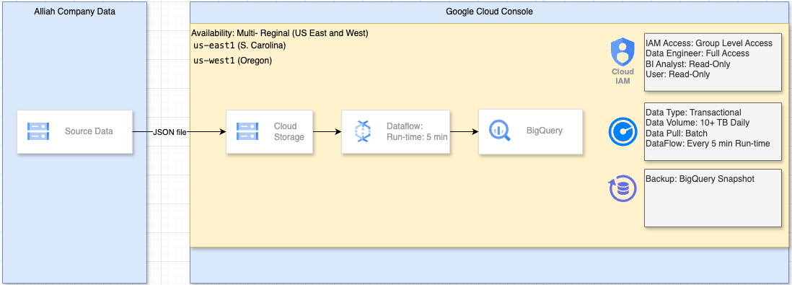
- Data Source
  - Details:
    - Source data is in JSON format, typically containing transactional records (e.g., customer purchases, timestamps, product details).
    - Files are uploaded to Google Cloud from:
      - E-commerce platform
      - CRM system exports
      - Vendor APIs (as JSON dumps)
  - Security:
    - Data is encrypted in transit using TLS during upload.
  - Business Justification:
    - JSON allows semi-structured data flexibility—ideal for Alliah’s varied data (customer info, order items, metadata).
- Data Storage – Cloud Storage (GCS)
  - Details:
    - JSON files are batch-uploaded to a Cloud Storage bucket (multi-regional).
  - Security:
    - IAM roles assigned by group:
      - Data Engineers: full access
      - BI Analysts: read-only
      - Users: read-only
    - Customer-managed encryption keys (CMEK) optionally used for sensitive data.
  - Availability:
    - Multi-regional bucket (e.g., US Multi-region) ensures redundancy and durability across geographically distributed zones.
  - Business Justification:
    - Scalable object storage for incoming data; durable and cost-effective.
    - Keeps data secure and highly available while maintaining control over access.
- Data Processing – Cloud Dataflow (ETL)
  - Details:
    - Apache Beam-based batch ETL job built in Cloud Dataflow.
    - Reads JSON files from GCS, performs:
      - Data validation (e.g., schema conformity, null checks)
      - Data cleansing (remove invalid records, correct typos)
      - Transformation (e.g., convert currency fields, enrich with timestamps, parse nested fields)
      - Deduplication (remove duplicate transaction IDs)
      - Partitioning fields
  - Security & Access:
    - Service account with IAM role
    - Group-level access via IAM bindings
    - Dataflow logs actions in Cloud Audit Logs for compliance tracking
  - Performance:
    - Autoscaling enabled to handle varying batch sizes
    - Job is triggered on schedule using Cloud Scheduler + Pub/Sub
    - Run Every 5 min: More cost efficient and close to real time.
  - Business Justification:
    - Fully managed, scalable ETL pipeline that ensures high-quality, cleansed data ends up in the warehouse.
    - Supports Alliah’s need for reliable, automated batch processing of large daily volumes.
- Data Warehouse – BigQuery
  - Details:
    - Cleaned and transformed data is loaded into a partitioned BigQuery table
    - Enables fast queries and cost-efficient scans.
    - The schema consists of several key tables with defined primary and foreign keys. These include: CUSTOMERS, with customer_id as the primary key; TRANSACTIONS, containing transaction_id as the primary key and customer_id as a foreign key; TRANSACTION_ITEMS, which references both transaction_id and product_id as foreign keys; and PRODUCTS, with product_id as the primary key.
  - Security & Compliance:
    - IAM policies enforced at dataset/table level:
      - BI Team: read access
      - Data Analysts: write access to staging datasets only
    - Column-level security for PII fields
    - Audit logs record query and access events
    - Supports GDPR, PCI-DSS, HIPAA, etc.
  - Backup & Snapshot:
    - BigQuery Table Snapshots taken daily before new loads (retain for 7 days)
    - Time Travel enabled: recover from accidental changes within 7 days
  - High Availability:
    - BigQuery is inherently multi-regional and serverless—designed for high availability and reliability.
  - Business Justification:
    - Centralized, secure analytics warehouse for Alliah’s business intelligence, marketing, and customer insights teams.
    - Scales automatically to handle 10+ TB of daily data

2. Identify which database objects need to be included. Create a logical data diagram to store the data in the proposed solution, including the objects identified in D2.
- CUSTOMERS
  - customer_id (PK)
  - name
  - email
  - phone
  - address
- TRANSACTIONS
  - transaction_id (PK)
  - customer_id (FK)
  - transaction_date
  - shipping_method
  - total_amount
  - shipping_method
- TRANSACTION_ITEMS
  - transaction_id (FK)
  - product_id (FK)
  - quantity
  - price
- PRODUCTS
  - product_id (PK)
  - vendor
  - product_category
  - product_name
Daigram:
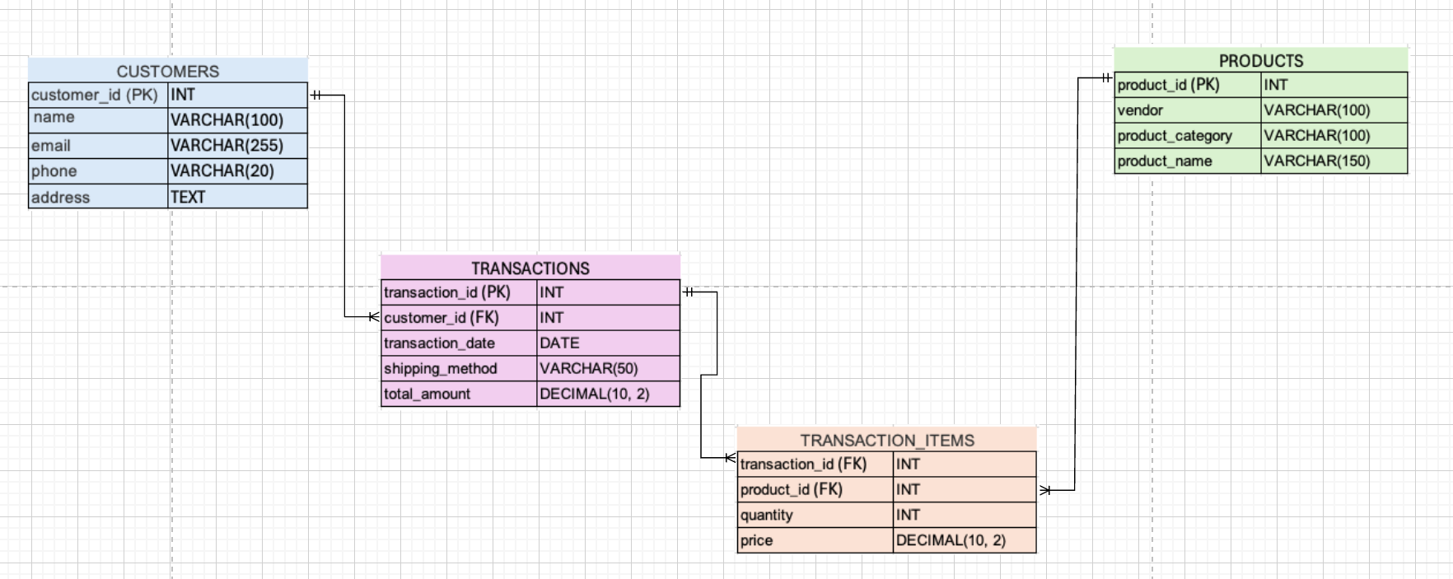
3. Explain why each of the database objects identified in part D2 needs to be included.
- Customers: Captures unique customers and contact information. Required for creating customer-level analytics
- Transactions: Core transactional records, capturing sales at the order level. Links to customers and includes metadata like date and shipping method.
- transaction_items: Breaks down each transaction into individual product purchases. Supports item-level analysis.
- Products: Stores all products referenced in the shopping carts. Enables filtering and aggregation by product type, category, or vendor.

Reference:
- External resources not used in this submission

